Gorham Country Club
2019
Men’s League Application
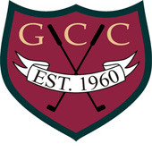

Name:_____________________________
Email:______________________________
Address:____________________________________
City:_________________ State:_________ Zip:___________
Home Phone:______________ Cell Phone:________________
GHIN#_________________ HDCP Index:_____ AVG Score:____
League Fee: Public Guests: $50.00
Members (If GHIN fee has been paid): $25.00
Payment Please Circle:
Cash
Credit Card#_____________________ Exp:_______ CVC#:____
Check: Payable To: Gorham Country Club
Address: 93 McLellan Road, Gorham ME 04038
Attn: Cindy Ahlquist
Important Dates
5/6/19 - League Meeting – 5:30PM
8/24/19- Banquet

