Gorham Country Club
2021
Men’s Match Play League Application
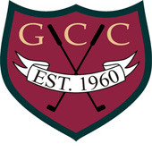

Name:_____________________________
Email:______________________________
Address:____________________________________
City:_________________ State:_________ Zip:___________
Home Phone:______________ Cell Phone:________________
GHIN#_________________ HDCP Index:_____ AVG Score:____
League Fee: Public Guests: $65.00 + GHIN fee
Weekly Greens Fees: $23
Payment Please Circle:
Cash
Credit Card#_____________________ Exp:_______ CVC#:____
Check: Payable To: Gorham Country Club
Address: 93 McLellan Road, Gorham ME 04038
Attn: Cindy Ahlquist
Important Dates
Monday, 5/3/21 - League Meeting – 5:30PM

