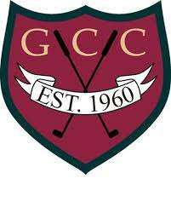
14th Annual Gorham Junior Open
August 11, 2021
Hosted by: GORHAM COUNTRY CLUB
PRIZES: First Place
Application Deadline
8/1/21
Second Place
Goodie Bag Provided to All
Entry Fees: Mail form/entry fee to:
Phone: 207-839-3490
Fax: 207-839-5567
infogorhamcc@maine.rr.com
$20.00 per player which includes: Gorham CC
- Greens Fee 93 McLellan Road
- Boxed Lunch Gorham, ME 04038
Four Divisions
*Championship Flight – Ages 16-18
A Flight – Ages 13-15
B Flight – Ages 9-12
C Flight – Ages 6-8
Handicap / Average Score__________________
Are you on a High School Golf Team_________
_____________________________________ Name of High School_____________________
Name
_____________________________________
Email
_____________________________________
Address Emergency Contact:______________________
_____________________________________ Emergency Contact Phone:_________________
City, State, Zip
______________________ ________________ Parents must sign form for children 17 and under
Phone Sex Age _______________________________________
*Cannot have graduated from High School as of July 1st, 2021 Signature of parent for children under 18- DATE

